1. The simulation “hyper-config” is executed, and I complied the following codes of “test1”. Then I executed test1, everything goes well.

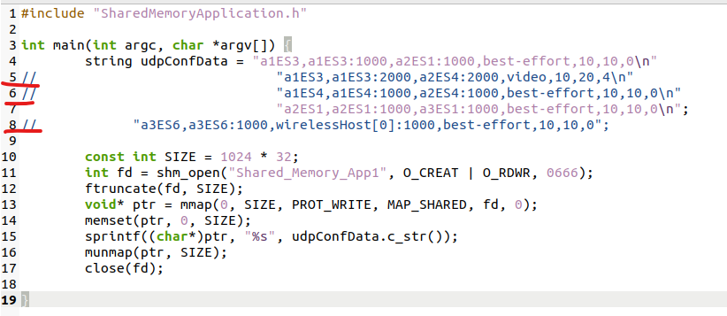

According to the project requirements, the UDP parameters can be modified during simulation runs. So I changed the codes of test1 as below, line5 is enabled.

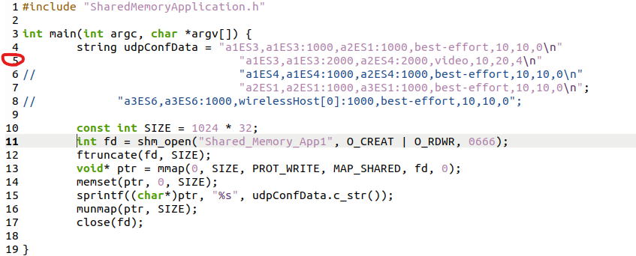

Then, I complied the codes, and executed test1, the following errors occur and the simulation is terminated abnormally.

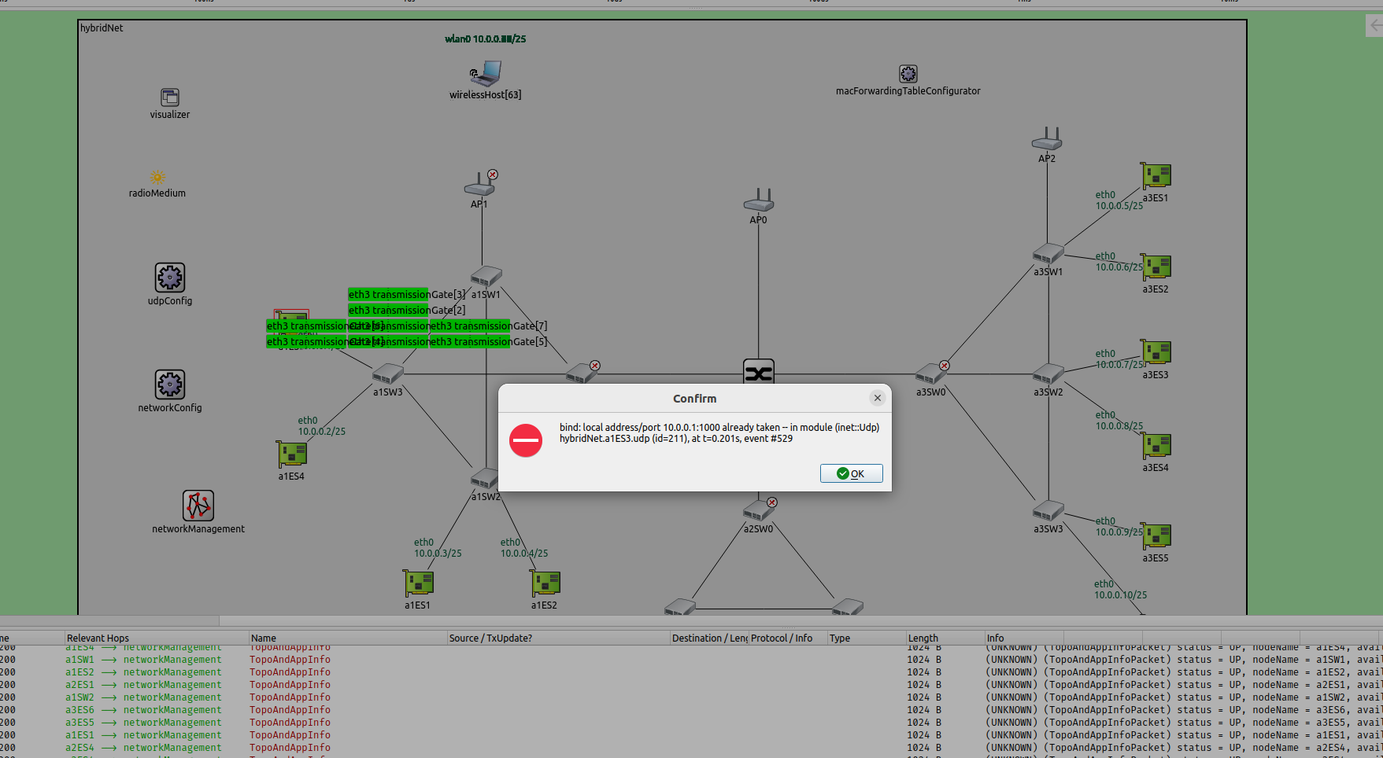

The error info is :  
bind: local address/port 10.0.0.1:1000 already taken -- in module (inet::Udp) hybridNet.a1ES3.udp (id=211), at t=0.201s, event #529

1. The topology discovery is not effective, please see the test below. I utilized two methods to test.

**Method1:** If a node goes offline or online, the topology discovery function should be activated to know which node is connected (goes online) or disconnected (goes offline). However, as shown in the below figure. “a1sw1, a1sw0, backbone_SW0, a3SW0 and so on” go offline, in other words, these nodes are offline. The offline nodes cannot transmit the message, but these nodes still transmit the message to “networkManagement”.

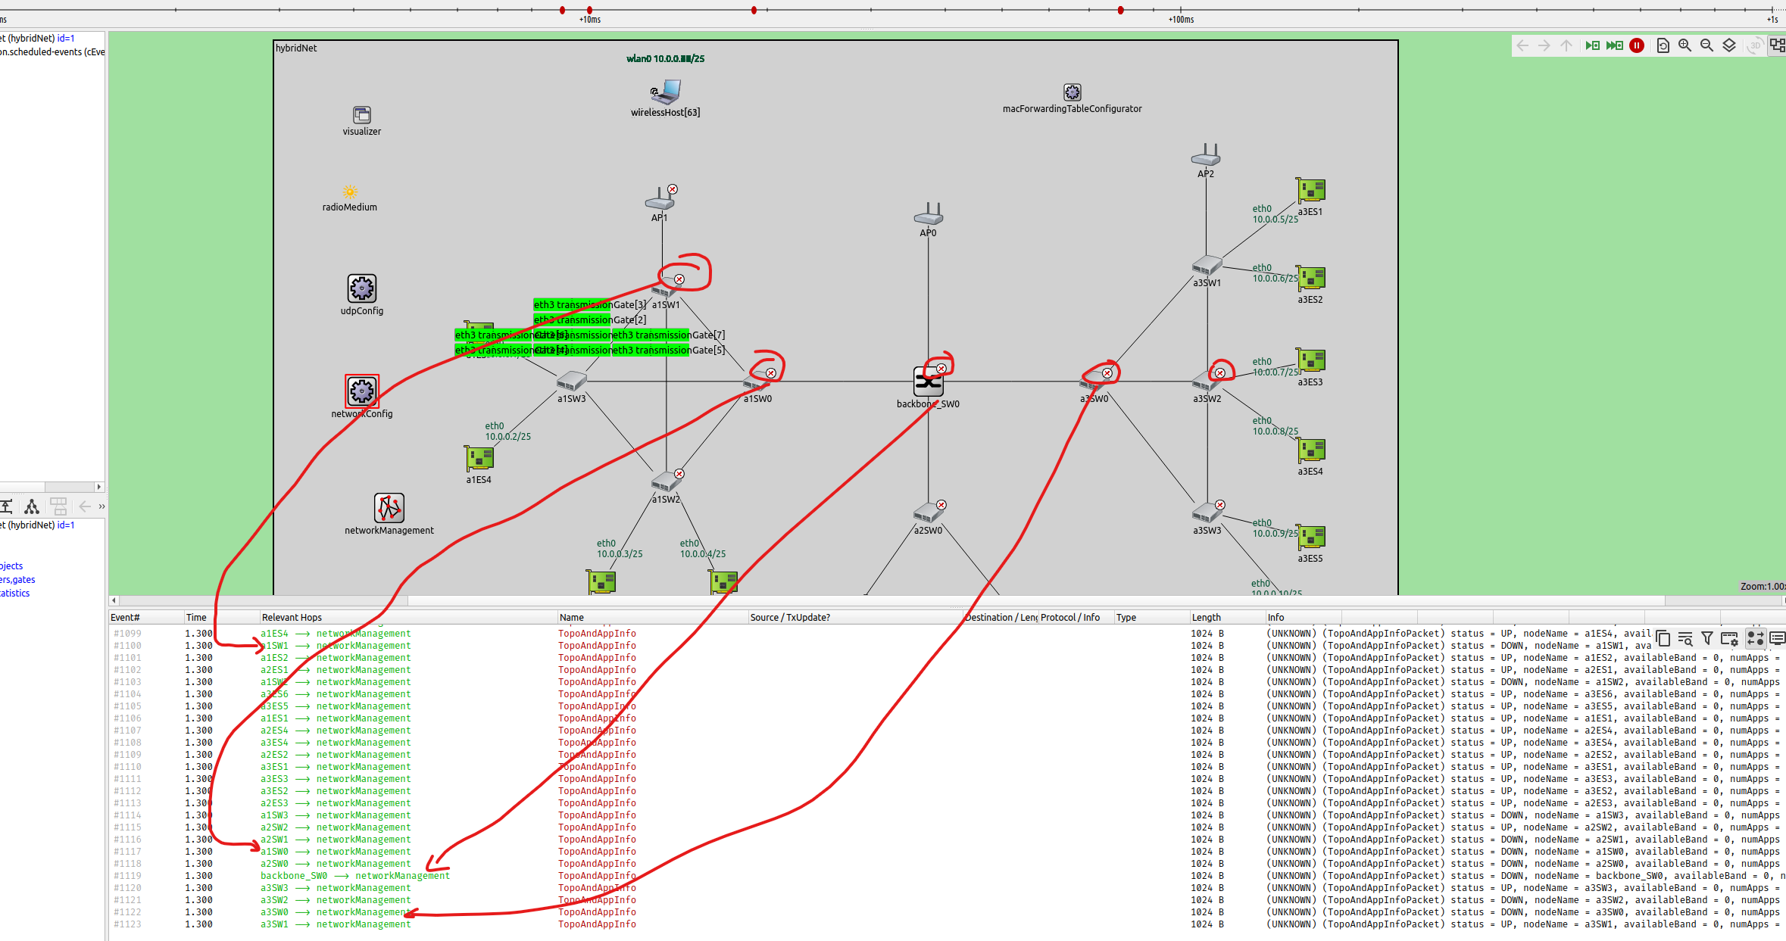

**Method2:**  I have modified the source codes of SharedMemoryApplication2.cc, the new file is named as “SharedMemoryApplication2-modified.cc”. The modified “test2” only prints the data if it has changed since the last read. The purpose is that, I want to see the JSON data when topology changes. In other words, if “topology discovery” feature works well, the modified “test2” will print the topology and app data when the topology is changed (some nodes go offline or online).

However, I executed the simulation and executed the modified “test2” for a quite long time. Even if the simulation topology is changed due to node failure, the JSON data contained in shared memory is always the same, not changed. But it should be changed as the topology changes.

1. Could you please explain the meaning of the following data as specified in Task 3? Please explain each element, i.e., the meaning of a1ES3, 0, 0, 1, 10.4, 4.3-6.2. Also the routing part should be explained.

gating,a1ES3,0,0,1,10.4,4.3-6.2\n

gating,a1ES3,0,1,1,10.3,4.2-6.4-7.8-8.9\n

gating,a1ES3,0,2,1,10.3,4.2-6.4-7.8-8.9\n

gating,a1ES3,0,3,1,10.3,4.2-6.4-7.8-8.9\n

gating,a1ES3,0,4,1,10.3,4.2-6.4-7.8-8.9\n

gating,a1SW3,3,0,0,11.5,200-300\n

gating,a1SW3,3,1,1,11.5,200-300\n

gating,a1SW3,3,2,0,11.5,200-300\n

gating,a1SW3,3,3,0,11.5,200-300\n

gating,a1SW3,3,4,0,11.5,200-300\n

gating,a1SW3,3,5,0,11.5,200-300\n

gating,a1SW3,3,6,0,11.5,200-300\n

gating,a1SW3,3,7,0,11.5,200-300\n

gating,a1SW3,1,1,0,11.5,200-300\n

routing,a2SW1,a3ES1,3

1. According to project requirement, the scheduling and routing parameters should be configured during simulation runs. So could you please do the following test?
   1. Execute simulation.
   2. Execute Test3.
   3. Modify the data in Test3, the compile it, and execute the Modified test3.
   4. See is there any bug.
2. In your report, you mentioned that payload contains name, length… see below:

1.The Payload should be configured by user, however, the current codes do not contain this feature.

Answer: As we know, payload information consists of packet name, packet length, send interval and priority. And this information is read from shared memory application 1 during simulation. (This is your answer)

My response: NO, you've got the wrong concept.

The payload of UDP refers to the actual data part transmitted in the UDP protocol.

A UDP message consists of four main parts: source port number, destination port number, length, and checksum. In addition to this header information, the remaining part is the payload.

1. Please provide the document of Task3-result statistics.
2. Please provide us a detailed program flow chart for three tasks.